FIRST set of each non-terminal:

Aim:
To write a C program to display the FIRST sets of all non-terminals in the given grammar.

Algorithm:
- Start the program.
- Define the grammar productions.
- Find the FIRST set of each non-terminal.
- Since \(A\) can derive epsilon, include the FIRST set of \(B\) in FIRST(S).
- Display the FIRST sets.
- Stop the program.

Pseudo Code:
BEGIN
DISPLAY grammar productions

FIRST(A) = {a, epsilon}
FIRST(B) = {c, d}

FIRST(S) = {a, c, d}

DISPLAY FIRST(S)
DISPLAY FIRST(A)
DISPLAY FIRST(B)
END

Code:
#include <stdio.h>
int main()
{
printf("Grammar:\n");
printf("S -> AB\n");
printf("A -> a | 8\n");
printf("B -> c | d\n\n");
printf("FIRST(S) = { a, c, d }\n");
printf("FIRST(A) = { a, 8 }\n");
printf("FIRST(B) = { c, d }\n");

return 0;
}

Output:
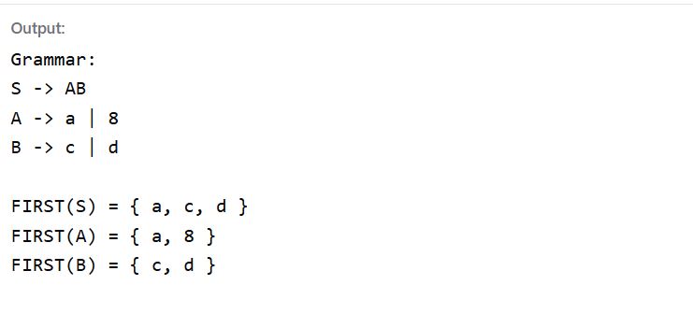

Result:
Thus, the C program was executed successfully to display the FIRST sets of all non-terminals in the given grammar.

